Paper Title
(14pt, Times New Roman, Capitalize First Word, Bold, Centered)
^{1#}Name of Author ^{2#}Name of Author ^{3#}Name of Author
Author Affiliation Author Affiliation Author Affiliation
e-mail e-mail e-mail
(Author name must be in 11 pt Regular font. Author affiliation must be in 10 pt Italic. Email address must be in 9 pt, Times New Roman)
ABSTRACT: An abstract should contain all information necessary for the reader to determine, the objectives of the study, how to approach the study, the result obtained and its significance. The typical length of an abstract is 150-200 words. The abstract should appear the beginning of the article. An abstract is a brief summary of a research article, any in depth analysis of a particular and is often used to help the reader quickly ascertain as the paper's purpose. (10pt, Times New Roman, single line spacing)

Keywords:key1;key2; key3; key4; key5 (Minimum 4 to 5 key words)

1. Introduction

The first section heading should beTimes New Roman12-point bold in small capital. Authors should submit your manuscript in (XXX.doc or XXX.docx) format. For questions on paper guidelines, please contact point Email urjeas@tuhpn.edu.mm (10pt, Times New Roman, single line spacing). The spacing between header and paragraph should be 3pt. The column spacing should be 0.3”.

2.Page Size
Top-1", Bottom-1",Right and Left is 0.75" A-4 Size.

2.1Formatting
This paper presents the font 10pt, Times New Roman, and line spacing is 1pt, and indentation for the first line is 0.5”)
Do not include headers, Footers or page numbers in your submission. These will be added when the publications are assembled.

2.2Figures and Tables

Place Tables/Figures/Images in text as close to the reference as possible(see Figure.1). Captions should be(10pt, Times New Roman, bold). They should be numbered(eg; "Table 1" or "Figure 1"),please note that the word for table and Figure are spelled out. Figure's captions should be centered beneath the image or picture, and Table captions should be centered above the Table body.
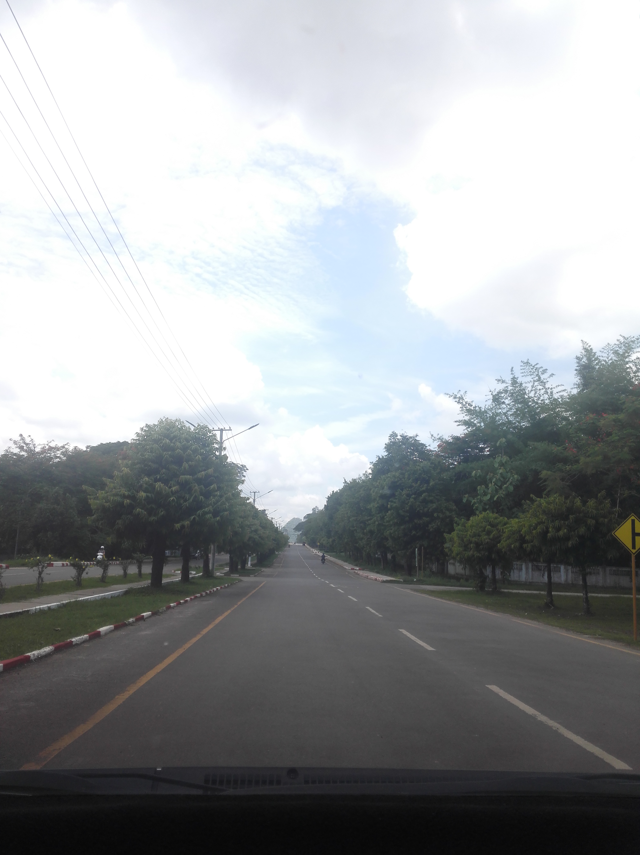

Figure 1. FigureCaptions Should Be Placed Below the Figure
Table 1.Table Captions Should Be Placed Above the Table
Des(9",bold) | Coln-1 | Coln-1 | Coln-1
Row-1 | (9",regular)
Row-2
Row-3

2.3. Mathematics
Math typesetting can be done by Equation Editor that produces clear math types (11pt Times New Roman and single line spacing)
P= VI (1)
All equations should be numbered, right justified.

3. First Order Heading
The heading of a section should be in Times New Roman 12- point bold in all capitals.

3.1. Second Order Heading
The heading of subsections should be in Times New Roman 11 point bold with each initial letter capitalized, flush left.Use a period (“.”) after the heading number, not a colon(As shown in above section 3.1.).

3.1.1. Third Order Heading
The heading of subsections should be in Times New Roman 10 point bold with each initial letter capitalized, flush left.Use a period (“.”) after the heading number, not a colon (As shown in above section 3.1.1.).

4. Abbreviations and Acronyms
Define abbreviations and acronyms the first time they are used in the text, even after they have been defined in the abstract. Abbreviations such as JICS do not have to be defined. Do not use abbreviations in the title unless they are unavoidable.

5.Conclusions
Although a conclusion may review the main points of the paper, do not replicate the abstract as the conclusion. A conclusion might elaborate on the important of the work or suggest applications and extensions.
6. Others
Do not number ACKNOLEDGMENTS and REFERENCES, and begin subheadings with letters.

7.References
List and number all bibliographical references in 9-point Times New Roman, single-spaced, at the end of your paper. Refer simply to the reference number, as in [2]. Where appropriate, include the name(s) of editors of referenced books.

[1] A. Bbbb, "research paper Title-1", Journal Name, Publisher, Location, Date/Year, pp-12-19.
[2] B. Cccc, "research paper Title-2", Journal Name, Publisher, Location, Date/Year, pp-4-10.
[3] C. Dddd, "research paper Title-3", Journal Name, Publisher, Location, Date/Year, pp-1-5.

