

The objectives of publishing the first University Research Journal of Engineering and Applied Sciences(URJEAS 2020)of TU(Hpa-an) are to contribute to the national development in one corner by bringing out practically applied researches in the sector of science and engineering ,to promote teaching pedagogies for faculty members, and to emerge the review papers that can help support for the students who need to do their graduation thesis.

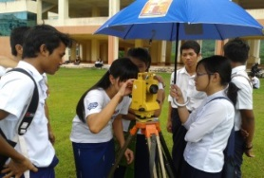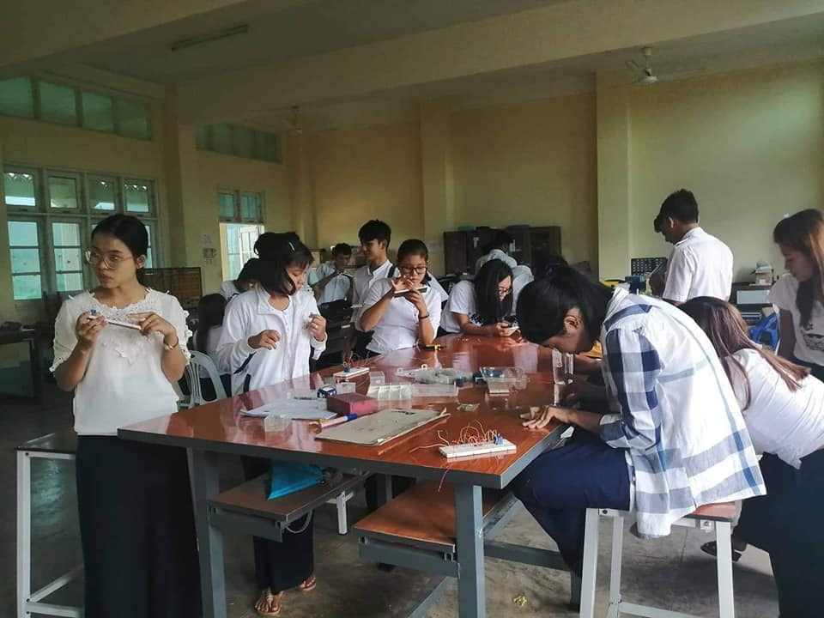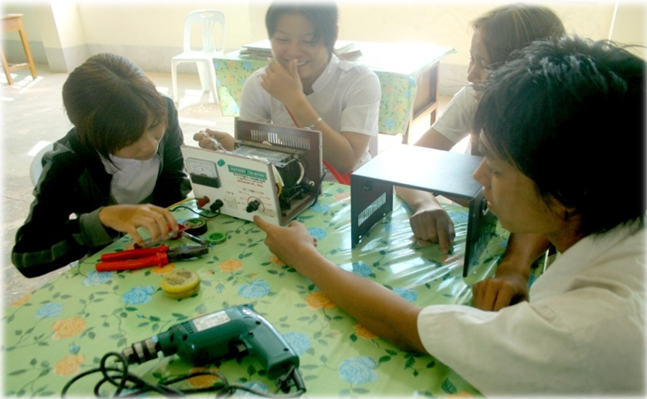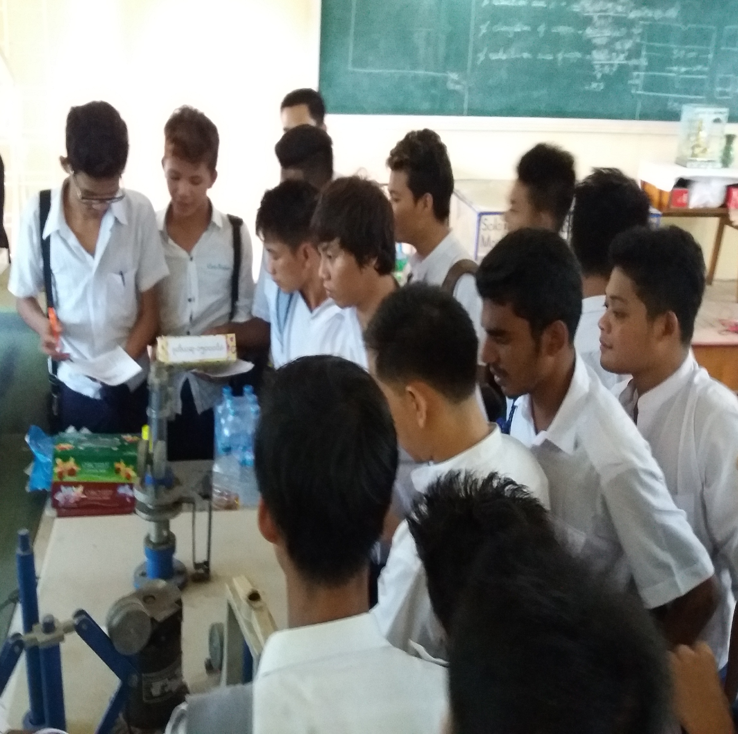

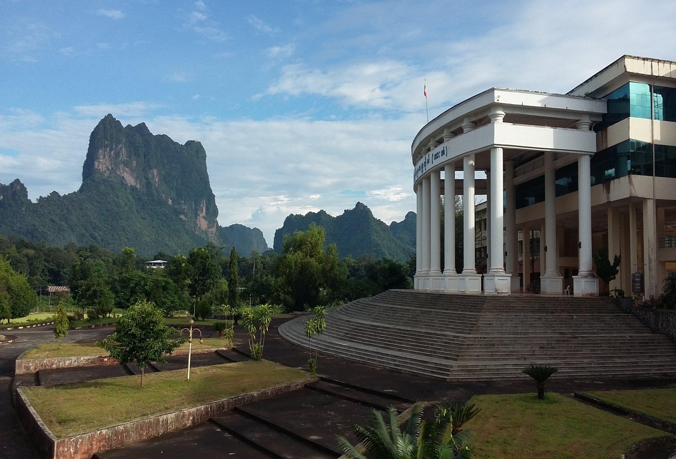

2ndUniversity Research Journal of Engineering and Applied Science (URJEAS)

Call for Papers

Technological University (Hpa-an)

**Technical Program Committee**

* Dr. Aung Zaw Latt, Pro Rector from TU(Hpa-An)
* Dr.Tin Win Mon, Pro Rector from TU(Kyaukse)
* Dr. Nyan Phone, Professor from TU(Thanlyin)
* Dr. Tint May Nway, Professor from YTU
* Dr. Lei Lei Yin Win, Professor from TU(Hinthada)
* Dr. Nu Nu Win, Professor from TU(Mawlamyine)
* Dr. Myint Myint Thwe, Professor from WYTU
* Dr. Aye Nandar Latt, Professor from TU(Toungoo)
* Dr. Naw Kay Thida Min, Professor from TU(Hinthada)
* Dr. Tin Hla Win, Professor from TU(Hpa.an)
* Dr. Mar Lar Thein Oo, Professor from TU (Hpa-An)
* Dr. Ruth Hta, Professor from TU(Hpa.an)
* Dr. Yin May, Professor from TU(Magway)
* Dr. Pyone Myat Khaing, Professor from TU(Hpa-An)
* Dr. Ohmmar Myint, Professor from WYTU
* Dr. Kyi May San, Professor from CU(Hpa-An)
* Daw Thida Oo, Associate Professor from WYTU
* Dr.Thida Aye, Associate Professor from TU(Hpa-An)
* Dr. Ohmmar Thin, Associate Professor from TU(Mawlamyine)
* Dr. San San Kyu, Associate Professor from TU(Hpa-An)
* Dr. Ni Ni Win, Associate Professor from TU(Meiktila)
* Dr. Nilar, Associate Professor from TU(Hpa-An)
* U Tun Lynn Aung, Associate Professor from TU(Hpa-An)
* U Aung Ko Htwe, Associate Professor from TU(Hpa-An)
* Daw Ei Ei Nway, Associate Professor from TU(Mawlamyine)
* Dr. Nan Pawt Sai Awar, Lecturer from TU(Hpa-An)
* Daw Phyo Hnin Thu Htun, Lecturer from TU(Hpa-An)
* Daw Khin Myo Myint, Lecturer from TU(Hpa-An)
* Daw Win Theingi Myint, Lecturer from TU(Hpa-An)

Secretariat Office Contact:

Email:**urjeas@tuhpn.edu.mm**

Phone no: 09 255810201

Registration Fees: 30000 Kyats

Bank Name: KBZ

Account Name: Dr. Khin Swe Win, Daw Win Theingi Myint

Account no. : 25230225200912401

Phone no. 09790584113

Full Paper Submission Start:

**1st Nov, 2020**

Last Date of Submission:

**30th Nov, 2020**

Pages: 4 **to 7 nos (MS Word)**

Plagiarism is not permitted more than 30% in the author's paper.

Remark: We will send reviewer’s comments to you and you can send us the updated paper within a week. And then the reviewer team will reply whether they are accepted or rejected via email: urjeas@tuhpn.edu.mm

**Interested Field**

* Civil Engineering
* Electronic Devices and Communication
* Embedded and Control System
* Electrical Power Engineering
* Solid Mechanics
* Renewable Energy
* Fluid Mechanics
* Manufacturing Engineering
* Thermal Engineering
* Engineering Mathematics
* Engineering Physics

(Except Nuclear)

* Engineering Chemistry
* Myanmar
* English