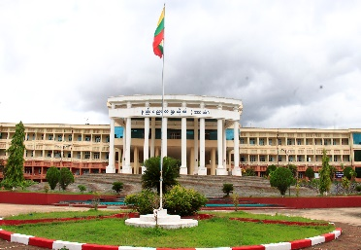

**Payment can be payable to:**

Bank: Myanmar Economic Bank (Hpa-an)

Name/ Kpay Name: Daw Shwe Zin Khaing, Kpay No: 09-763112915

NRC No: 10/Ma Da Na (N) 163487

**Registration Fees: 35000 Kyats**

* Start Date of Full Paper Submission: 1st May,2024
* Full Paper Submission Deadline: 31st July, 2024
* Notification for Paper Acceptance: 31st August, 2024
* Fees payment: 1st to 6th September, 2024
* Journal Publication: September, 2024

**Important Dates**

**Technical Program Committee**

* Dr. Aung Zaw Latt, Pro-Rector, TU (Hpa-an)
* Dr. Thet Mar Htun, Pro-Rector, CU (Maubin)
* Dr. Nay Myo Kyaw Thu, Professor, TU (Mawlamyine)
* Dr. Aye Aye Nwe, Professor, TU (Taunggyi)
* Dr. Soe Win, Professor, YTU
* Dr. Than Than Htay, Professor, TU (Meiktila)
* Dr. Soe Yee Win, Professor, YUDE
* U Aung Kyaw Myint, Professor, TU (Kyaukse)
* Dr. Nu Nu Lwin, Associate Professor, TU (Mawlamyine)
* Daw Tin Mar Lwin, Associate Professor, WYTU
* Dr. Khin Su Su Wai, Professor, TU (Hpa-an)
* Dr. Seint Seint Htwe, Professor, TU (Hpa-an)
* Dr. Nyein Nyein Soe, Professor, TU (Hpa-an)
* Dr. Mi Aye Su Khaing, Professor, TU (Hpa-an)
* Dr. Thin Thin Hlaing, Associate Professor, TU (Hpa-an)
* Daw Aye Thida Myint, Associate Professor, TU (Hpa-an)
* Daw Ngu Wah Wah Htun, Associate Professor, TU (Hpa-an)
* Daw Cho Cho Hsan, Associate Professor, TU (Hpa-an)
* Daw Thae Thae Ei, Lecturer, TU (Hpa-an)
* Daw War War Win, Registrar, TU (Hpa-an)

Secretariat Office Contact:

email: [nyeinnsoe@gmail.com](mailto:nyeinnsoe@gmail.com)

Phone No: 09-250205255

* URJEAS welcomes author’s submission of papers concerning any branch of Research on Engineering and Applied Science.
* The number of pages must be **within 5 to 7 pages in Microsoft Word file format.**
* Plagiarism is not permitted more than **40 %.**
* You must submit your paper through the **email: nyeinnsoe@gmail.com**
* After submission, URJEAS, 2024 will send you reviewer’s comments within (3) weeks of submission and you have to send us the updated paper within a week.

**Interested Field**

* Civil Engineering
* Electronic Devices and Communication
* Embedded and Control System
* Electrical Power Engineering
* Solid Mechanics
* Renewable Energy
* Fluid Mechanics
* Manufacturing Engineering
* Thermal Engineering
* Engineering Mathematics
* Engineering Physics (except nuclear)
* Engineering Chemistry
* Myanmar
* English

The Objectives of publishing the 4th University Research Journal of Engineering and Applied Science (URJEAS, 2024) of TU (Hpa-an) are to contribute to the national development in one corner by bringing out practically applied researches in the sector of science and engineering, to promote teaching pedagogies for faculty members, and to emerge the review papers that can help support for the students who need to do their graduation thesis.

(URJEAS, Volume 4)



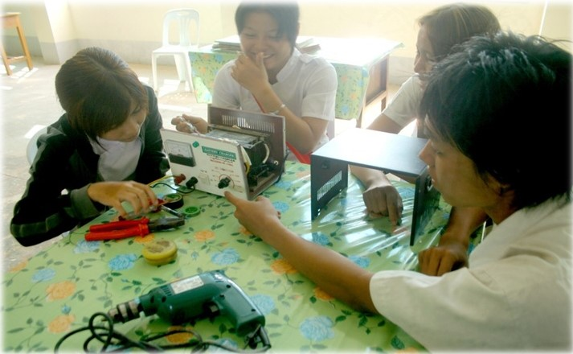

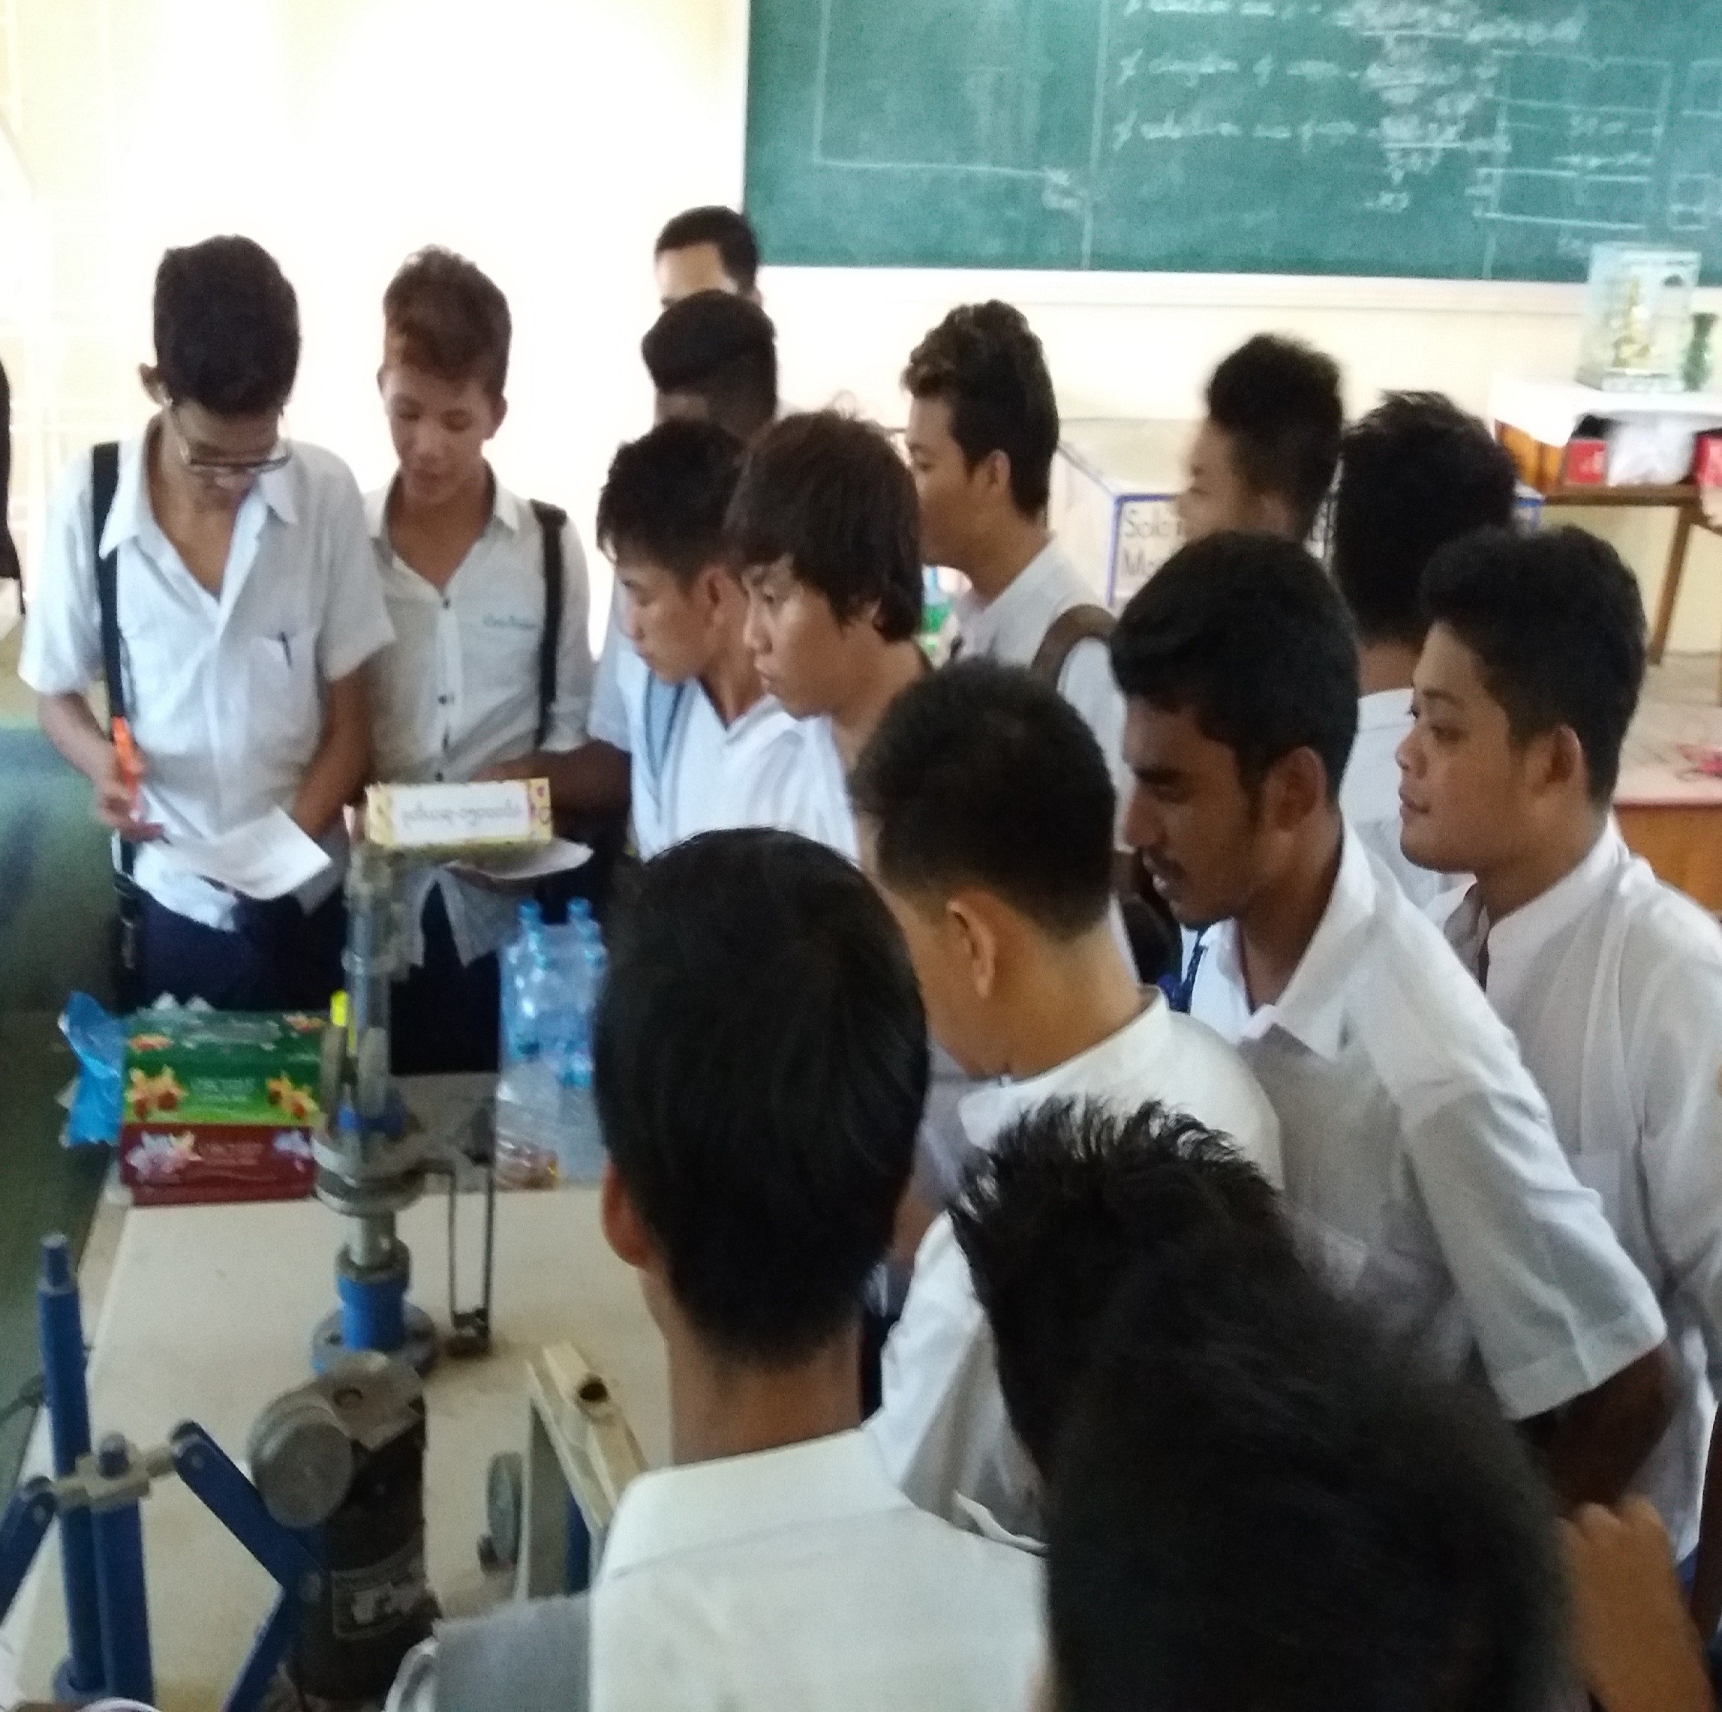

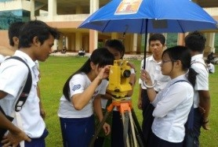

**Call for Papers**

The 4th University Research Journal of Engineering and Applied Science

Technological University (Hpa-an)